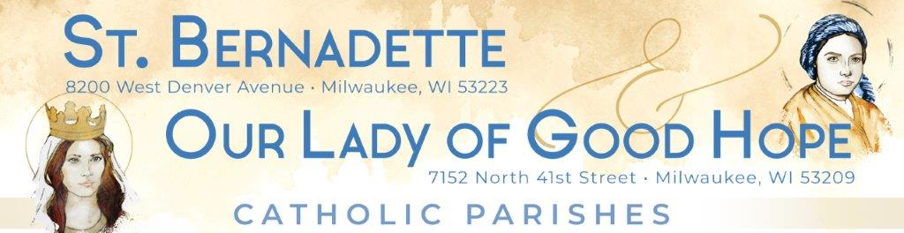
September 2022 Update
The strategic planning process which began in October 2021 continues to move forward. Working toward a shared vision of a vibrant Catholic presence in Northwest Milwaukee continues as the focus of our efforts.
Since our last update…
- The steering committees for St. Catherine of Alexandria (StCA) and for St. Bernadette (StB)/Our Lady of Good Hope (OLGH) met on September 22nd to discuss the official completion of the “as is” portion of the strategic plan and to recognize the contributions made by all parishioners in this process.

- Those in attendance shared both hopes and concerns for collaborating together.

  - Some themes surrounding hopes for our collaboration were growth, accepting change, and creating a stronger Catholic presence.
  - Some themes surrounding concerns for our collaboration were imposing decisions on parishioners, financial impacts, and the loss of any members of our communities.

- The opportunity to begin relationship building with each other was a focus of the meeting.

- A new Special Assignments workgroup was announced. This workgroup was formed to work on feasibility studies for future state ideas.
Coming up…
- Workgroups and steering committees will be wrapping up any outstanding items before we move into the future state.

- A new Joint Strategic Tri-Parish Steering Committee will be formed by the third week in October. This committee, which will include representatives from all three parishes, will need to be strategically focused on the overall community that we are called to serve. The current OLGH/StB Steering Committee and the StCA Steering Committee will be dissolved.

- Workgroups from StCA, StB, and OLGH will be combined and will work on future state together. They will begin developing future state plans by the end of October.
Side notes of interest…
- Northwest Catholic School exceeded their enrollment goal with 202 students enrolled for the coming school year, an increase of 26 students over last school year. If you attend Mass at OLGH, please pray with a student by selecting a prayer from the prayer chain that is located in the vestibule of the church.
- After consultation and discussion with StCA, our new hymnals are on order, but we continue to collect donations to defray the cost. As of September 18th, parishioners have donated $6,420 toward our combined goal of $9,000. Thank you for your generosity!
“Consult not your fears, but your hopes and dreams. Think not about your frustrations, but about your unfulfilled potential. Concern yourself not with what you tried and failed in, but with what it is still possible for you to do.” Pope Saint John XXIII

